Exp. No: 3 Determination and plotting of Force of attraction between two electric Charges and two parallel conductors separated by varying distance.

Aim:
To Determination and plotting of Force of attraction between two electric Charges and two parallel conductors separated by varying distance between them using SCILAB.

Software required:•SCILAB version 6.0.1

Pratical Calculation:

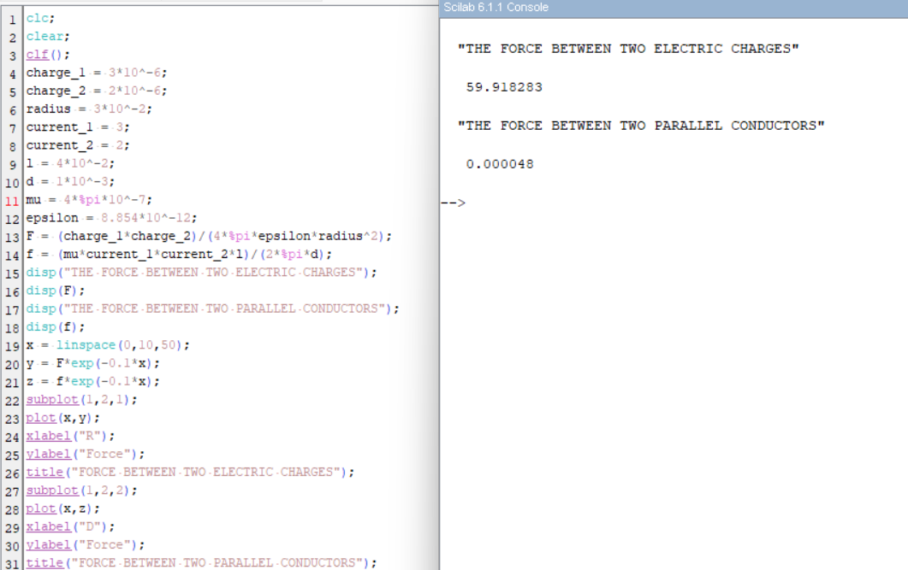

Theoritial Calculations:
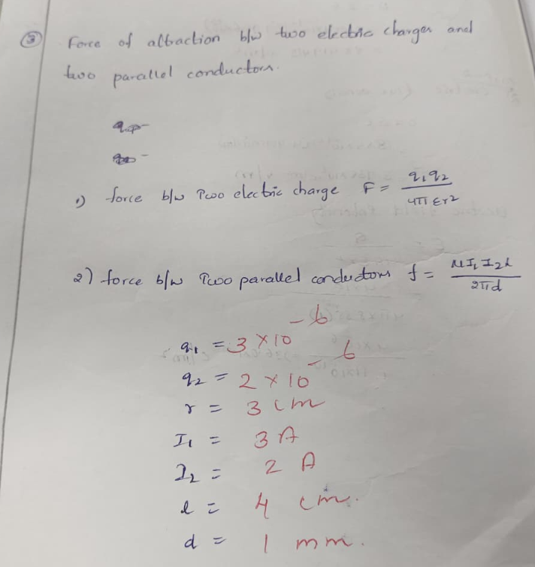
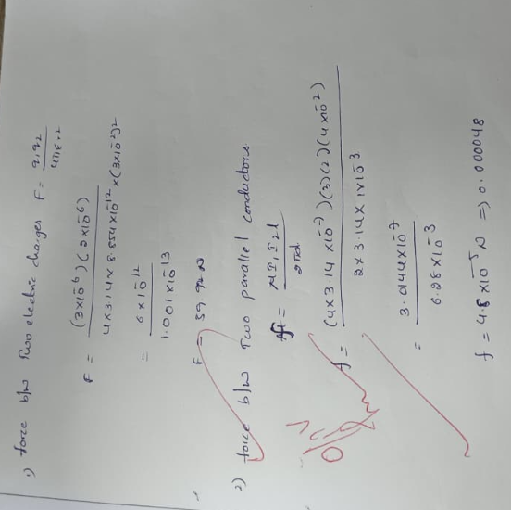

Result: :Thus the program was verified for the force of attraction or repulsion acting along a straight line between two electric charges is directly proportional to the product of the charges and inversely to the square of the distance between them using SCILAB was successfully.

